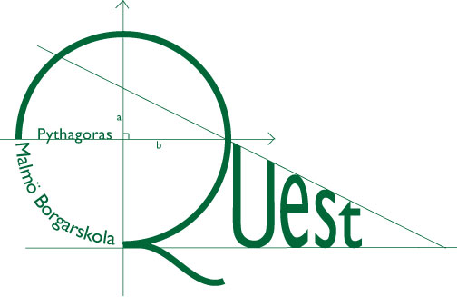
PYTHAGORAS QUEST
Riksfinal
Part 1. Time: 60 min – 7 Questions Max points: 21 (3p/question).
Allowed tools: Paper, pencil and rubber (no calculator).
Write your solutions on separate pieces of paper. Write your team name on each sheet of paper.
Please show full working for your answers to Part 1.

Karl's Party
Karl and his five friends are sitting at a round table. They then stand up, and then sit down again at the table. They notice, however, that Karl is sitting at the same place as he was before, but that nobody has the same neighbours as they did before the move.
In how many different ways can they be seated after the move?

2016 number 1

Let us call a rational number of the form $\frac{p}{q}$ beautiful if the fraction has been expressed in its lowest terms (e.g. 1/3 instead of 2/6).
What beautiful fractions are there such that pq = 2016?

Crushed Circle

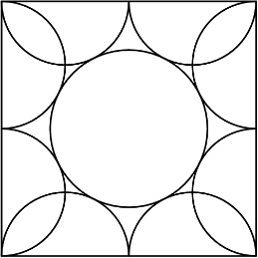
In the figure to the right, there are eight semi-circles of radius 1 unit inside a square of side length four units. Inscribed inside these semi-circles, is circle such that it is at a tangent to all eight semi-circles. What is the radius of the inner circle?

2016 number 2

Let the three first numbers in a number sequence be 2050, 2051 and 2052. The next number in the sequence is given by adding the number two steps before it to the number three steps before it then subtracting the number just before it. For example, the fourth number is given by$2050+2051-2052=2049$ and the fifth number is given by $2051+2052-2049=2054$.
What number is at place 2016?

Malte's Special Sequence

Malte has invented a special number sequence where the first number is the number 1. To get the second number he says "one one" and writes down what he says i.e. "1 1". He carries on by saying "Two ones" and write down "2 1". The next number in the sequence will be 1211 and 111221 and so on like in the table below.

He says... | He writes...
“One one” | 1 1
“two ones” | 2 1
“One two one one” | 1 2 1 1
“One one one two two ones” | 1 1 1 2 2 1
In this sequence, will there ever be three threes in a row?

The Non Triangle Problem

A set is a group of numbers. Let a set be triangular if you can choose three different whole numbers from the set which could form sides of a triangle. From the set {4, 5, 6, 7, 8 } you could chose the numbers 4,7,8 which would make up the sides on a triangle. Given the set

{4, 5, 6, ... , n}

What is the smallest whole number n such that you can choose six numbers from this set to make a new set, such that the new set is not triangular?

A,b,c,d ....

7. Let a, b, c and d be different positive whole numbers such that
a⁵ = b⁴, c³ = d² and c - a = 19.
What are a, b, c and d?

