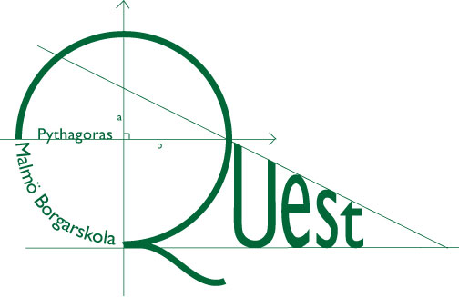
PYTHAGORAS QUEST
National Final
Part 2. Time : 30 min – 7 questions Max: 14 points (2p/question).
Allowed tools: Only paper, pencil and rubber
Write your team name on all sheets of paper.
Answers only for Part 2.

The Rhombus
In the rhombus ABCD (below), the angle DAB = 60º and in the rhombus DEBF the angle BED = 120º. If the area of DEBF is 3, what is the area of the rhombus ABCD?
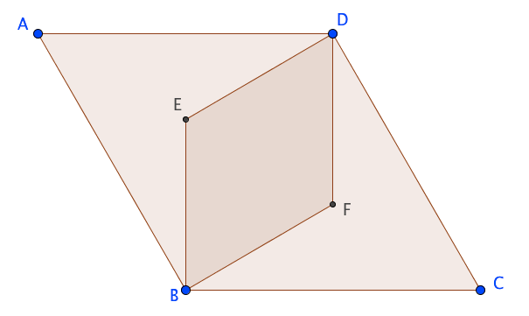

PIN-Code
2. Sam, being a forgetful person, is standing at the cash machine and has forgotten his 4 digit PIN code. The digits he could use are 0 to 9. What is the probability that he guesses the correct code at the third attempt, given that he has already guessed the wrong code at the previous two attempts?

How old is Lisa?

For one sixth of her life, Lisa was at school. She spent another twelfth of her life studying at university and yet another seventh of her life conducting research. She didn't reach 100 years old. How old was Lisa when she died? (Assume that she went to school/university/researched for a whole number of years)

Election Time

Every student at Borgar voted in the Borgar Elections. Everyone who voted for the Lars Party liked Lars. Among those who voted for the other parties, 20% liked Lars anyway (because he is a nice guy). What percentage voted for Lars Party if 52% of all the students at Borgar liked Lars?

Coin + Dice = True

Two coins are tossed at the same time. For each coims that shows a 'tail', you then throw a dice. What is the probability that the sum of spots on the dice is an odd number? (Note that if the dice isn't thrown then it shows 0 spots.)

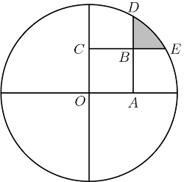
Lars and Malte's Geometry Problem

When Lars and Malte finally manage to pull their finger out and construct a geometry problem, they come up with the diagram to the right. The circle has radius 2 and OABC is a square of length 1. It also turns out that angle DOE = 30⁰. What is the area of the shaded region?

a, b, c, d, e

Suppose that a < b < c < d < e are five consecutive positive whole numbers such that b + c + d is a square number and a + b + c + d + e is a cube number.

What is the smallest whole number a which satisfies these conditions?

