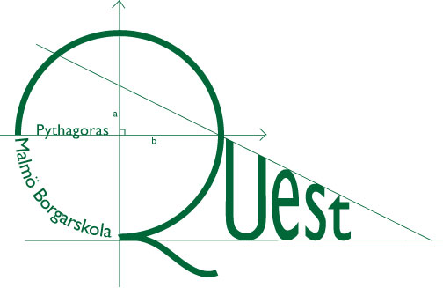
PYTHAGORAS QUEST
National Final

Part 3 Max time: 10 min
Decider Question
Calculator and other digital tools, not allowed.
If two teams have the same points after Parts 1 and 2, then this counts as the decider question. In the first place, correct answers are considered. Secondly the team that solved it in the shortest possible time will be placed before the other team(s).

Let a₁=20, a₂=16 and a_{n}=a_{n-1} - a_{n-2}, when n > 2.
What is a₁ + a₂ + ... + a₂₀₁₆?

